DHCP Snooping and Dynamic ARP Inspection

DHCP Snooping
Prevents unauthorized DHCP servers from joining your network.
In Cisco switches, DHCP snooping is enabled manually. Trusted ports should be manually configured and the rest unconfigured ports are considered untrusted ports. Most devices connected to trusted ports are routers, switches, and servers. DHCP clients like PC and laptops are commonly connected to an untrusted port.

How it works is that it will allow DHCP server messages like DHCPOFFER and DHCPACK that are coming from a trusted source. If the DHCP server messages are coming from untrusted ports, it will discard the DHCP traffic. The switch creates a table called the DHCP Snooping Binding Database. The DHCP snooping database registers the source MAC address and IP address of the hosts that are connected to an untrusted port.

DHCP Snooping Theory
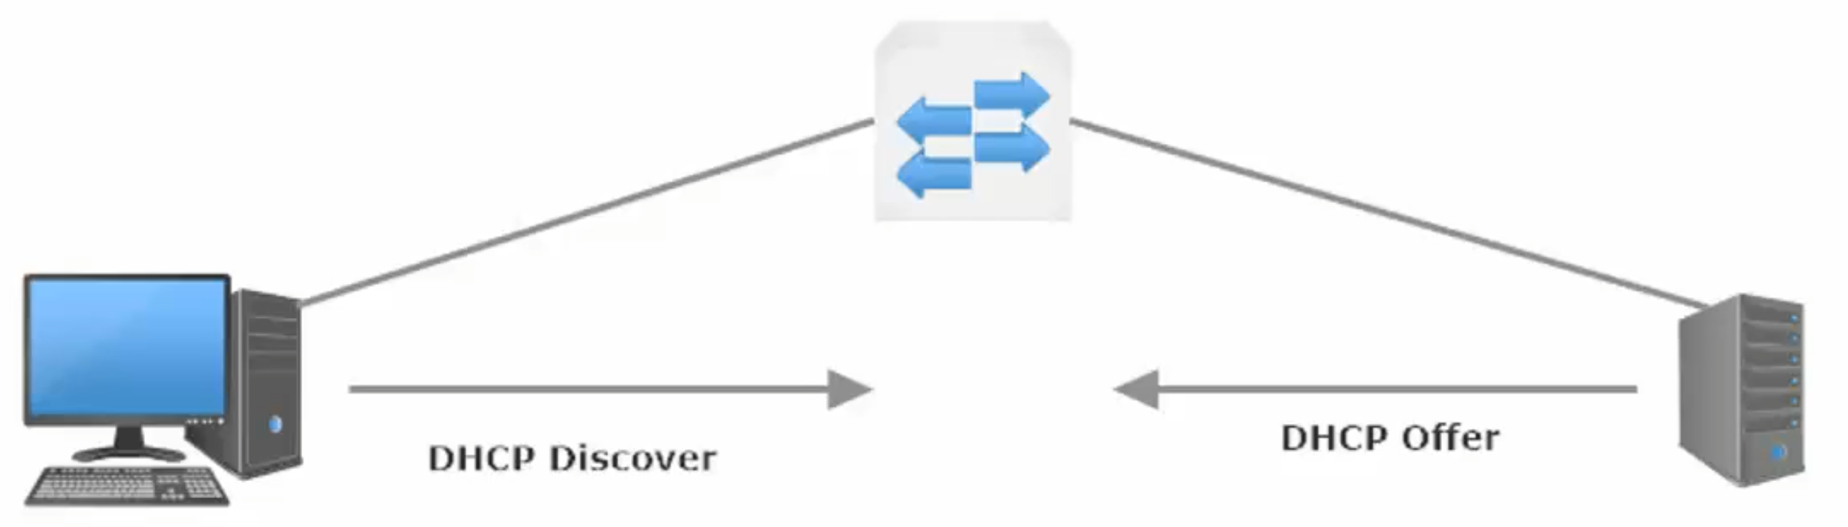
DHCP_Discover Packet is broadcast to
So_IP: 0.0.0.0
De_IP: 255.255.255.255
So_MAC: Host Mac Address
De_MAC: FF:FF:FF:FF:FF
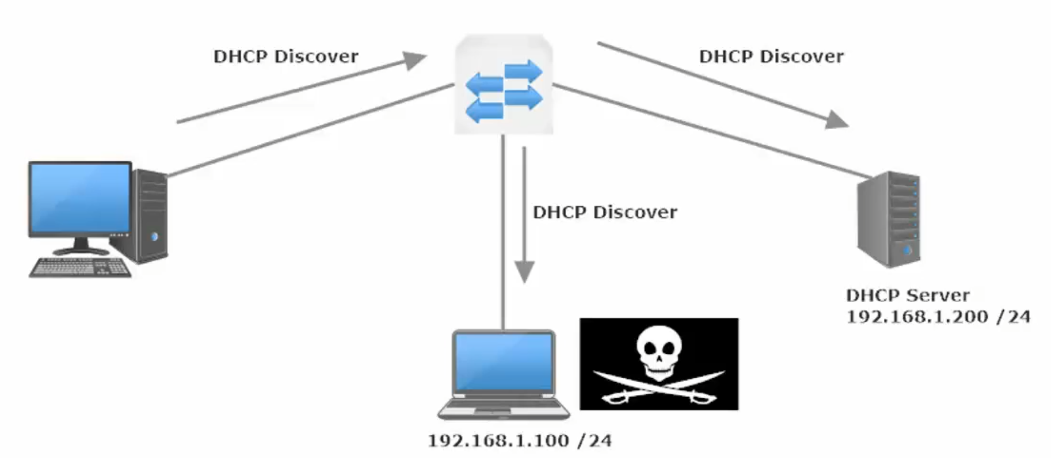
As such the man in the middle at .100 gets the Disc Packet and could respond with a rogue DHCP Offer.

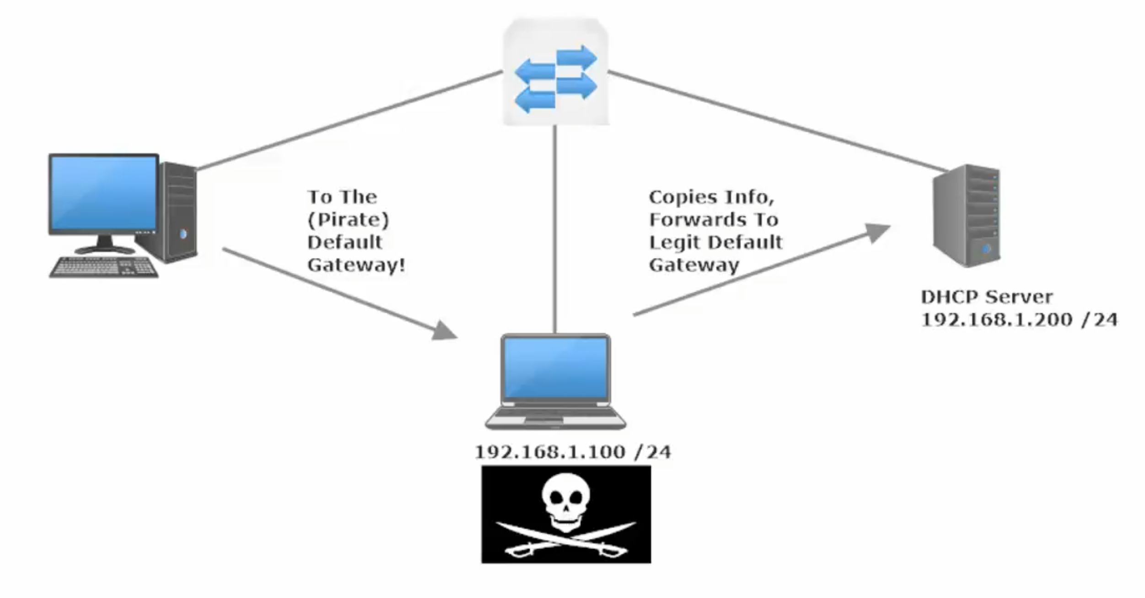
The DHCP Offer coming from the pirate will list the Pirate as the Default Gateway. Meaning the Host will send all traffic through the true default gateway on to the non-legit hacker Default Gateway.
Man in the Middle Attack / Reconnaissance Attack – collects info/packets and uses this info towards a further attack.

DHCP Snooping
Configured on switches, since those are typically devices between the hosts and the DHCP servers / relay agents
Uses the concept of trusted / untrusted ports (similar to port-security) (MAC address used as key)
Ports are untrusted by default
Must be enabled globally and then on a per-interface level
Typically, you’ll trust ports rec messages from DHCP Servers and leave untrusted ports to receive DHCP messages from clients.
On a trusted port, all DHCP messages (DORA + Release + Decline) flow freely.

Release – sent by client to release the IP address it leased from a DHCP Server
Decline – sent by client because a duplicate IP has been detected by the client

Client Messages – Disc + Request + Decline + Release
Server Messages – Offer + Acknowledge

Remember: DHCP Messages sourced from a client are treated differently than those sourced from a server on untrusted ports.

DHCP Server Messages >> arrive on untrusted port >> discarded (Implicit Deny unless explicitly Permitted)
DHCP Client Messages >> on untrusted port >> generally can flow, but may be blocked if Snooping process considers them dangerous.

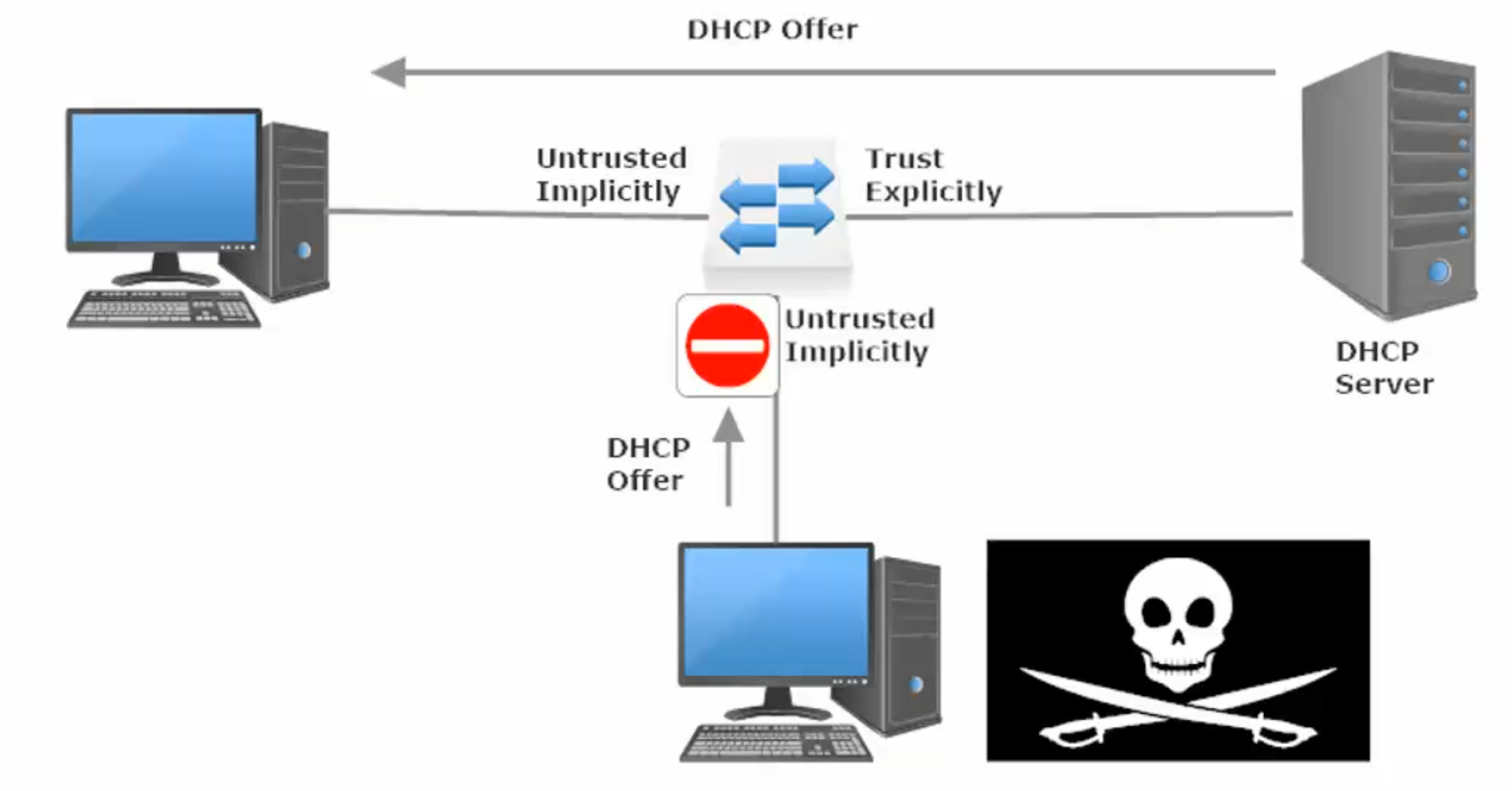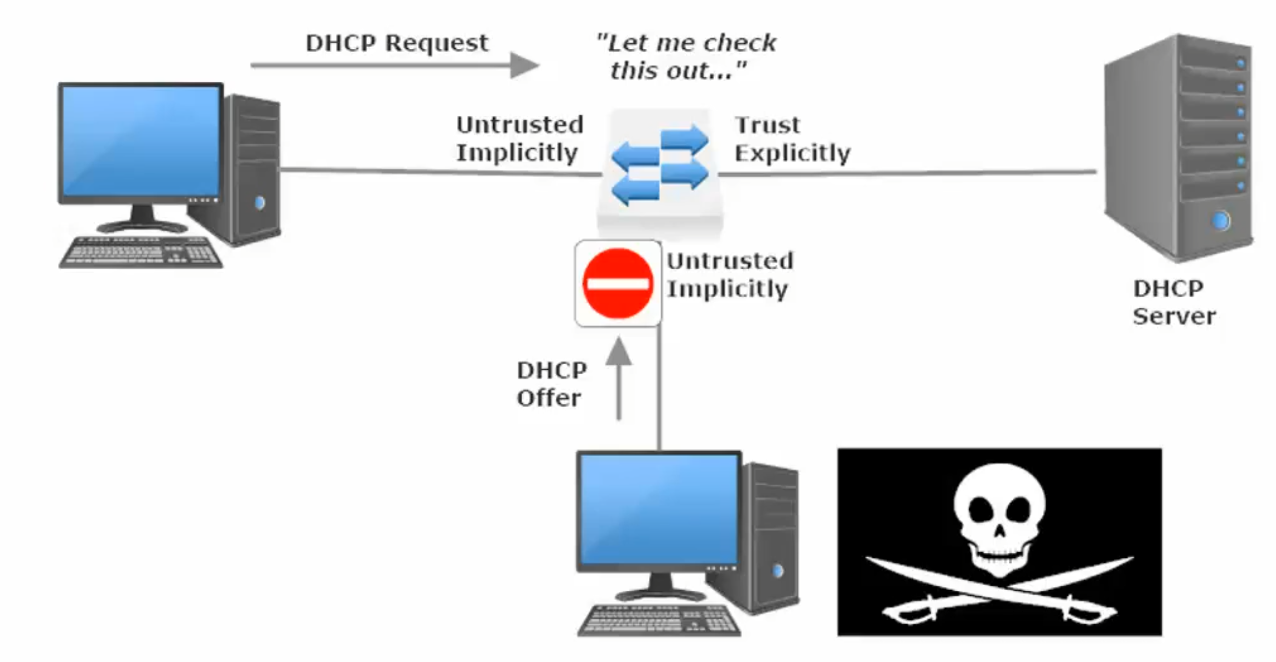

Compares the client ID (for the MAC) and the ETH Encapsulation (contains the Source MAC) and deny if they do not match

Example of another DHCP Attack
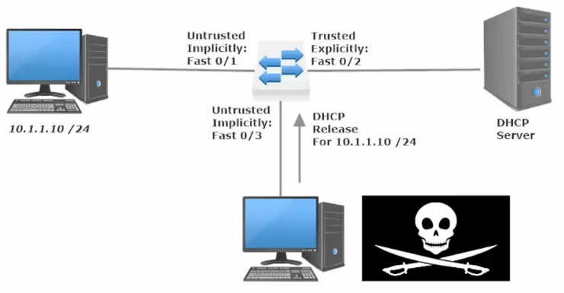
Attacker sends DCHP release packet (this packets orginate from DHCP Clients) to attempt to force a DHCP handshake and complete a Man-in-the-middle attack.
However, the port on the Sw where the lease for 10.1.1.10 originated was Fa0/1 and now Fa0/3 is attempting to send a release packet, which alerts the DHCP snooping agent which then denies the DHCP release.

DHCP Snooping Rate Limit
Used to prevent a Denial of Service (DoS) attack by flooding an interface with tons of DHCP discover requests
Enabled on a per-interface basis, can be set on trusted or untrusted interfaces
Sw(config)#int g0/0
Sw(config-if)#ip dhcp snooping rate limit 10

When configuring DHCP snooping rate limiting on a Layer 2 LAN interface, note the following information:

- We recommend an untrusted rate limit of not more than 100 packets per second (pps).

- If you configure rate limiting for trusted interfaces, you might need to increase the rate limit on trunk ports carrying more than one VLAN on which DHCP snooping is enabled.

- DHCP snooping puts ports where the rate limit is exceeded into the error-disabled state.

IP ARP Inspection Lab

You enable ARP inspection globally for specific VLANs

Sw(config)#ip arp inspection vlan 1

Specify what the ARP inspection will validate against (src-mac | dst-mac | ip) globally

Sw(config)#ip arp inspection validate (src-mac)

And then from the interface-config mode for individual interface you elect whether the interface will be trusted.
If not explicitly trusted, then the interface (if on a VLAN with ARP inspection active) will be implicitly not trusted.

Sw(config-if)#ip arp inspection trust

Multiple ways for ARP inspection to validate whether an ARP packet is legitimate.
These way are set with the “ip arp inspection validate <dst-mac> or <src-mac> or <ip> command (from global-config mode) If you only select one option in the command, only that option will be enabled.

Example: Sw1(config)#ip arp inspection src-mac will enable the source-mac validation, but it you then
enable IP validation with another command (Sw1(config)#ip arp inspection ip), src-mac validation gets disabled and ip validation gets enabled.

To enable multiple validation options, you must do so in one command (order doesn’t matter)
Example: Sw1(config)#ip arp inspection validate ip src-mac dst-mac (Enables All 3 options)

Sw1(config)#ip arp inspection validate ?
dst-mac Validate destination MAC address

src-mac Validate source MAC address

ip – Validate IP address

Checks for unexpected and invalid IP addresses, including (0.0.0.0) and (255.255.255.255) and all multicast add

Checks sender IP in ARP Request and Responses
Checks destination IP in ARP Responses

Optional additional signifier for IP validation: #ip arp inspection ip allow zeros
Allows the (0.0.0.0) sender/source IP address. Necessary for DHCP to work.

dst-mac – Validate destination MAC address

Validates the destination MAC address in the Ethernet header to the target MAC address in the ARP message (ARP Responses only)

src-mac - Validate source MAC address

Validates the source MAC address in the Ethernet header to the sender MAC in ARP Requests and Responses

If a mis match is detected under any of these optional validation techniques, the offending packet is dropped.
The packet is dropped, but the interface stays UP, there is no err-disabled state)

OPTIONAL | ARP Request | ARP Response
IP | Checks sender IP in ARP Request | Checks sender IP in ARP Responses  Checks destination IP in ARP Responses
DST-MAC | N/A | Validates Dest MAC (in the Ethernet Header)  to Target MAC (in the ARP Response)
SRC-MAC | Validates Source MAC (Eth Header)  To the Sender MAC (ARP Request) | Validates Source MAC (Eth Header)  To the Sender MAC (ARP Response)

The IP validation option has the ‘allow zeros’ option to allow a source IP of 0.0.0.0 through the ARP inspection protections.

